Date: DD/MM/YYYY

Lab Session No.: 03

**Aim:**

Develop an android application to demonstrate the Implicit and Explicit Intent.

**Software’s /IDE Tools:**

Android Development Kit / Android Studio

**Application User interface design:**

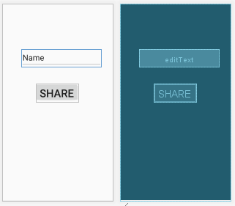

**Application Programming Interface:**

|  |  |  |  |
| --- | --- | --- | --- |
| **API / PACKAGES** | **CLASSES / INTERFACES** | **METHODS** | **DESCRIPTION** |
| import androidx.appcompat.app.AppCompatActivity; | AppCompatActivity | protected void onCreate(Bundle savedInstanceState) | onCreate(Bundle) is where you initialize your activity. When Activity is started and application is not loaded, then both onCreate() methods will be called. |
|  |  |
| import android.widget.EditText; | EditText | getText() | Determines the minimum type that getText() will return. If set, specifies that this TextView has a textual input method and should automatically capitalize what the user types. |

**Code/Implementation:**

// Develop an android application to demonstrate the Implicit and Explicit Intent.

// Project Name : ShareMyApp

/*

Lab Session No. : 03

Author : Pratap

Date : DD/MM/YYYY

Roll Number : XXX

Description : Implementation of Intents

Softwares required :

Android Studio

Topics Covered :

Implicit Intents and Explicit Intents

*/

*MainAcitivity.java*

**package** com.example.sharemyapp;  
  
**import** androidx.appcompat.app.AppCompatActivity;  
  
**import** android.os.Bundle;  
**import** android.view.View;  
**import** android.widget.EditText;  
**import** android.widget.Button;  
**import** android.content.Intent;  
  
**public class** MainActivity **extends** AppCompatActivity **implements** View.OnClickListener {  
  
 Button **b**;  
 EditText **e**;  
  
 @Override  
 **protected void** onCreate(Bundle savedInstanceState) {  
 **super**.onCreate(savedInstanceState);  
 setContentView(R.layout.***activity_main***);  
 **b**=(Button)findViewById(R.id.***button***);  
 **e**=(EditText)findViewById(R.id.***editText***);  
 **b**.setOnClickListener(**this**);  
 }  
  
 @Override  
 **public void** onClick(View v) {  
 **if**(v.getId()==R.id.***button***) {  
 String result=**e**.getText().toString();  
 Intent shareIntent=**new** Intent();  
 shareIntent.setAction(Intent.***ACTION_SEND***);  
 shareIntent.putExtra(Intent.***EXTRA_TEXT***,result);  
 shareIntent.setType(**"text/plain"**);  
 startActivity(shareIntent.*createChooser*(shareIntent,**"Share to"**));  
 }  
  
 }  
}

*activity_main.xml*

*<?***xml version="1.0" encoding="utf-8"***?>*<**androidx.constraintlayout.widget.ConstraintLayout xmlns:android="http://schemas.android.com/apk/res/android"  
 xmlns:app="http://schemas.android.com/apk/res-auto"  
 xmlns:tools="http://schemas.android.com/tools"  
 android:layout_width="match_parent"  
 android:layout_height="match_parent"  
 tools:context=".MainActivity"**>  
  
 <**EditText  
 android:id="@+id/editText"  
 android:layout_width="297dp"  
 android:layout_height="65dp"  
 android:layout_marginStart="72dp"  
 android:layout_marginTop="168dp"  
 android:ems="10"  
 android:inputType="textPersonName"  
 android:text="Name"  
 android:textSize="30sp"  
 app:layout_constraintStart_toStartOf="parent"  
 app:layout_constraintTop_toTopOf="parent"** />  
  
 <**Button  
 android:id="@+id/button"  
 android:layout_width="158dp"  
 android:layout_height="67dp"  
 android:layout_marginStart="124dp"  
 android:layout_marginTop="296dp"  
 android:text="Share"  
 android:textSize="40sp"  
 app:layout_constraintStart_toStartOf="parent"  
 app:layout_constraintTop_toTopOf="parent"** />  
</**androidx.constraintlayout.widget.ConstraintLayout**>

**Output:**

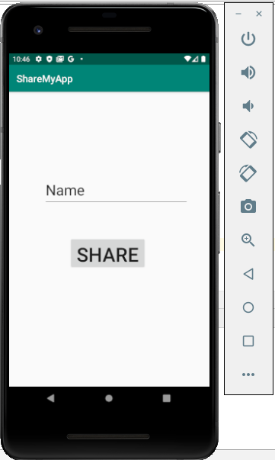 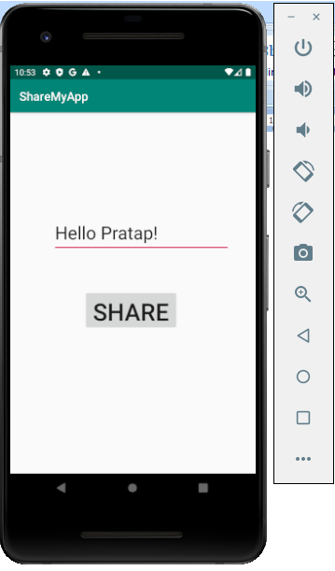 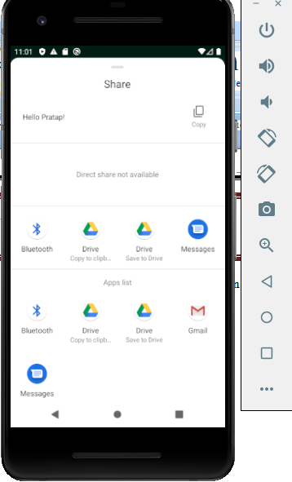

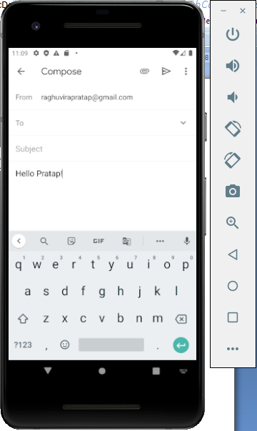 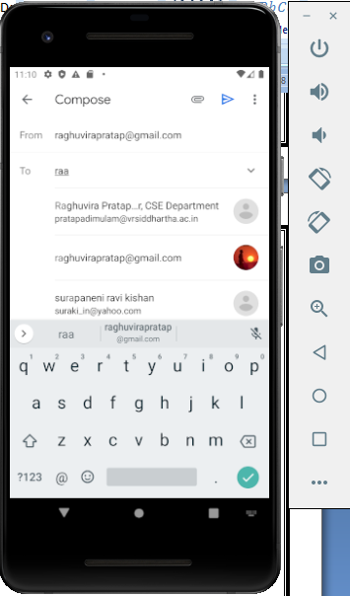

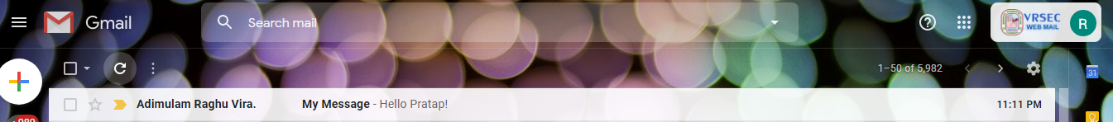

**Result:**

Demonstration the Implicit and Explicit Intents were done successfully.